| **Test Name** | | Game does not pay out at correct level |
| --- | --- | --- |
| **Use Case Tested:** | | Play Game |
| **Test Description:** | | When player wins on 1 match, balance does not increases |
| **Pre-conditions** | | The program has been launched, and is currently running.  Registered user can only get chance to Play game.  The balance must be positive which is greater than the minimum bet. |
| **Post-conditions** | | The output console has been filled with information from the demo runs of the program.  The post conditions here are reliant on the return value of the dice. |
| **Cases:** | * Cases   + If No 'Crown' is rolled i.e. 0 matches: Then the result = -5.Now, the player balance decreases by bet amount (-$5) and the final balance is $95   + If 1 'Crown' is rolled i.e. 1 match: Then the result = 5.Now, the player balance increases by bet amount ($5) and the final balance is $105   + If 2 'Crown' is rolled i.e. 2 match: Then the result = 10.Now, the player balance increases by bet amount ($10) and the final balance is $110   + If 3 'Crown' is rolled i.e. 3 match: Then the result = 15.Now, the player balance increases by bet amount ($15) and the final balance is $115 | |

**Script Steps**

|  |  |  |  |
| --- | --- | --- | --- |
|  | **TEST STEP** | **EXPECTED TEST RESULTS** | **RESULT** |
| 1. | Main.java is run. | Console opens and results are displayed on the output.  100 games are shown on the output. | Pass |
| 2. | Play round (Pick ‘crown’, bet 5) | A result (winnings amount) and 3 new dice values | Pass |
| 3. | Check result  (dice values and winnings amount) | The wining amount is correct based on the dice values given below:   * 0 crowns – Winnings = -5 * 1 crown – Winnings = 5 * 2 crowns – Winnings = 10 * 3 crowns – Winnings = 15 | Fail |
| 4. | Player balance is checked | Make confirmation with player balance is altered by winnings amount | Fail |
| 5. | Repeat steps 3 & 4 until only 1 match occurs and verify result | Confirm winnings for 1 match = 5 and player balance is increased by 5. | Fail |

**Source of BUG**

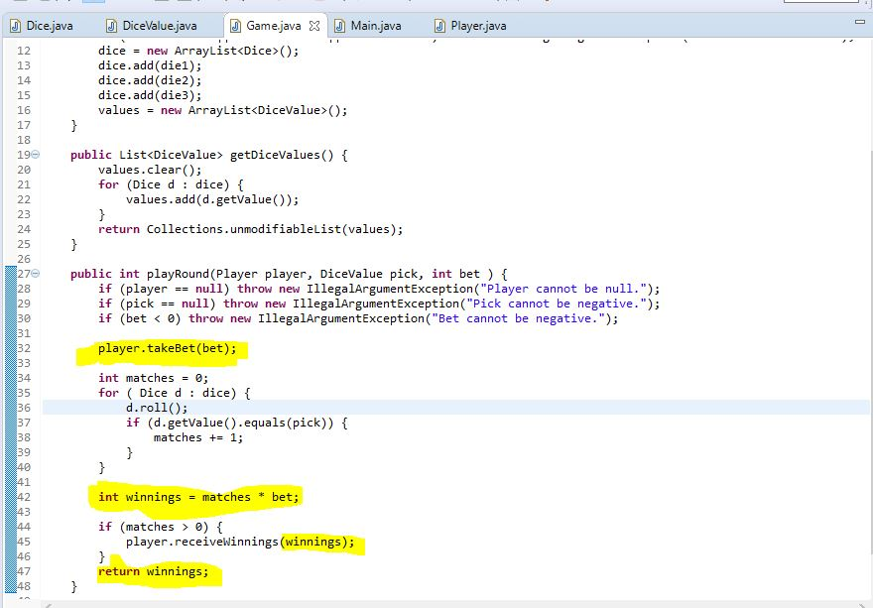

**Examples of BUG:**

|  |  |
| --- | --- |
| **EXAMPLES OF BUGS** | **RESULT** |
| bug 1 eg 1.JPG | Fred's Initial balance: 100  sBalance after turn: 100  Expected: 105  Result: FAIL |
| bug 1 eg 2.JPG | Fred's Initial balance: 40  Balance after turn: 40  Expected: 45  Result: FAIL |